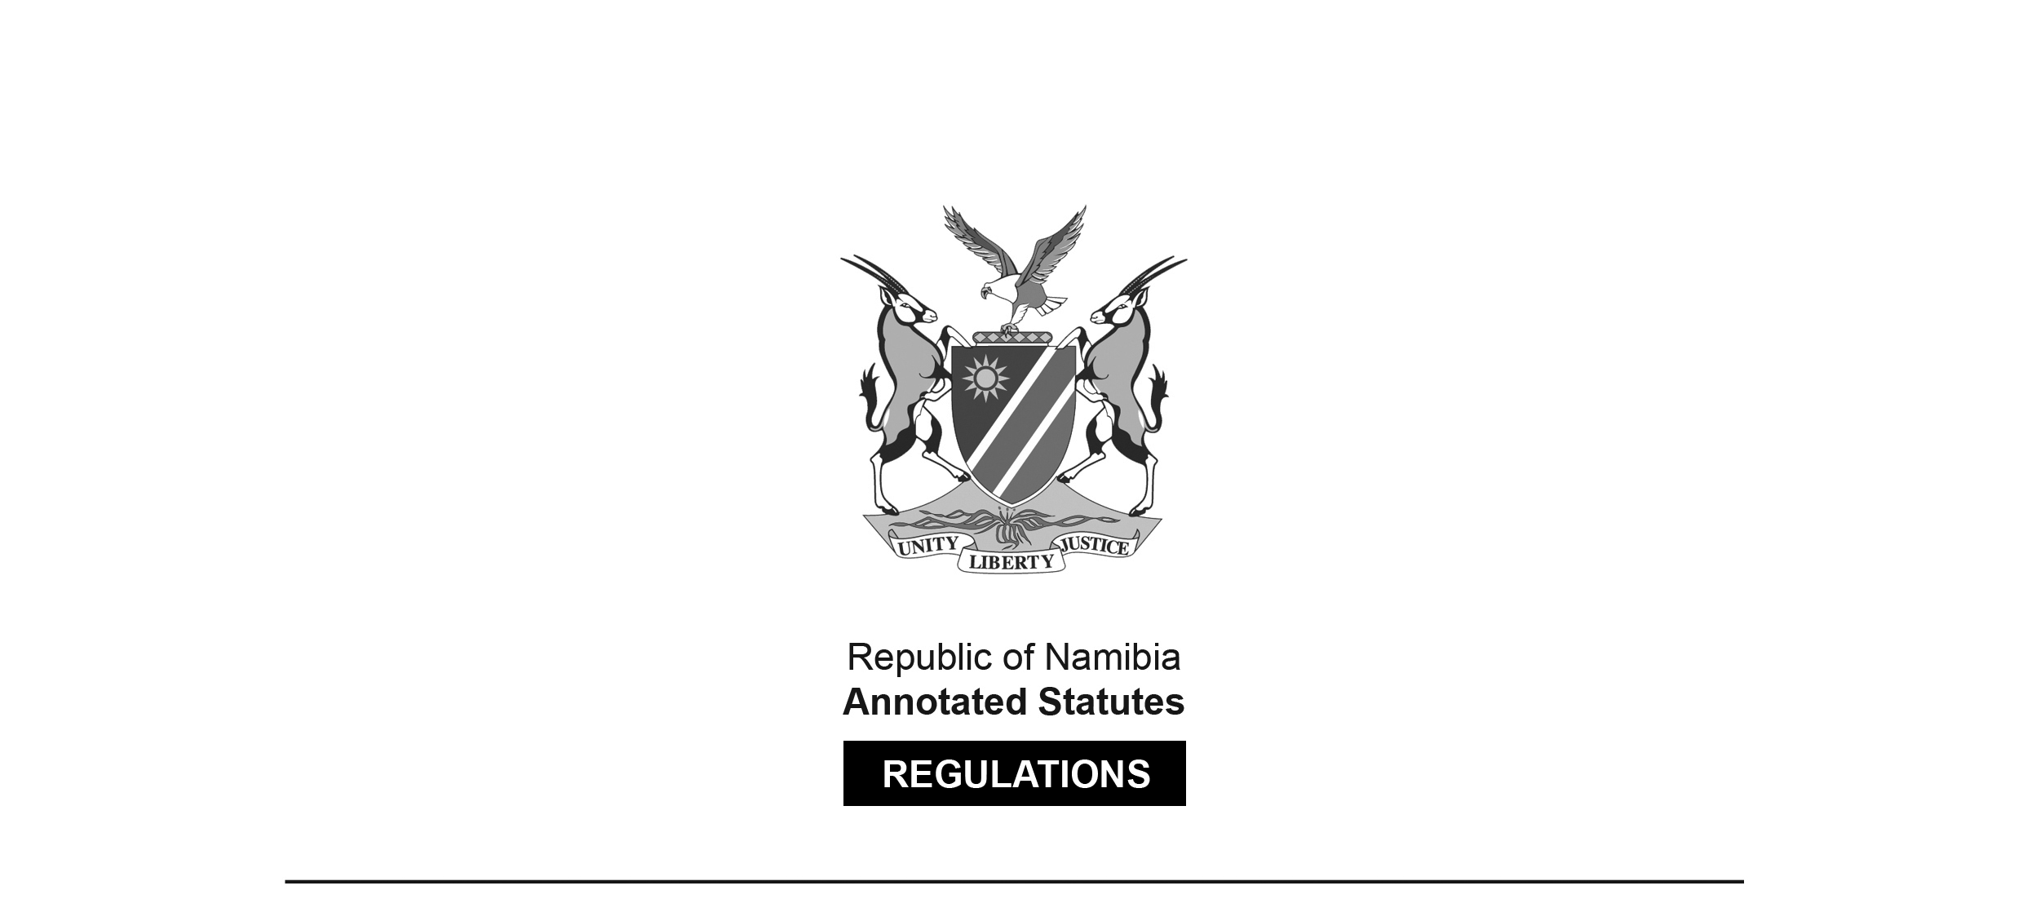

REGULATIONS SURVIVING IN TERMS OF

Health Professions Act 16 of 2024

section 95(10)

Regulations relating to the Scope of Practice   
of a Dispensing Optician

Government Notice 105 of 2011

([GG 4752](http://www.lac.org.na/laws/2011/4752.pdf))

came into force on date of publication: 13 July 2011

These regulations were made in terms of section 55 of the Allied Health Professions Act 7 of 2004, which was repealed by the Health Professions Act 16 of 2024. Pursuant to section 95(10) of the Health Professions Act 16 of 2024, they are deemed to have been made under that Act.

The Government Notice which publishes these regulations notes that they were made   
on the recommendation of the Allied Health Professions Council of Namibia.

ARRANGEMENT OF REGULATIONS

1. Definitions

2. Scope of practice of a dispensing optician

**Definitions**

**1.** In these regulations, unless the context otherwise indicates, a word or expression defined in the Act has that meaning.

**Scope of practice of a dispensing optician**

**2.** (1) The acts especially pertaining to a dispensing optician in the conducting of his or her practice, are -

(a) the provision, directly to the public, of spectacles, spectacle frames and spectacle lenses designed or intended to correct errors of refraction in the human eye;

(b) the performance of facial measurements for the purpose of the adjustment of spectacle frames;

(c) the repair or replacement of spectacles, spectacle frames and spectacle lenses; and

(d) the sale and fitting of optical appliances, excluding, subject to subregulation (2), the sale and fitting of piano contact lenses,

on the prescription of a registered ophthalmologist or optometrist.

(2) Notwithstanding paragraph (d) of subregulation (1), a dispensing optician who is the holder of the prescribed additional qualification, Advanced Contact Lens Diploma, may sell and fit, on the prescription of a registered ophthalmologist or optometrist, plano contact lenses.